**Weekend Assignment**

**Design a database for the following scenario. (Conceptual + Logical + Physical Phase)**

The client manages a couple of dental offices. One is called the Jawlakhel Office, the other the Putalisadak Office. The client needs the system to manage its patients and appointments, alerting the patients when and where their appointments occur, either by email or by phone, and then assisting in the selection of new appointments. The client wants to be able to keep up with the records of all the patients’ appointments without having to maintain lots of files. The dentists might spend time at each of the offices throughout the week. For each appointment, the client needs to have everything documented that went on and then invoice the patient.

Currently, the client uses a patient number in its computer system that corresponds to a particular folder that has the patient’s records. The system needs to track and manage several dentists and quite a few dental hygienists who the client needs to allocate to each appointment as well.

* **Conceptual Modeling :**

Here, we list out possible entities and their relationships.

1. Identifying Entities:

* dental_office
* dentist
* dental_hygienist
* patient
* appointment
* invoice

2. Defining Business Rules from requirements:

* two dental offices ( Jawlakhel and Putalisadak)
* patient gets appointed via phone or email
* dentist might spend a week at each offices
* dental hygienists are assigned to appointments
* invoice is generated per appointments
* patients pays the amount in invoice

3. Conceptual Model:

* dental_office has many dentists
* patient can have appointments
* dentist is assigned to many appointments
* dental hygienist is assigned to many appointments
* an appointment has fixed dentist and dental hygienist
* invoice is generated per appointments
* invoice is paid by respective patient

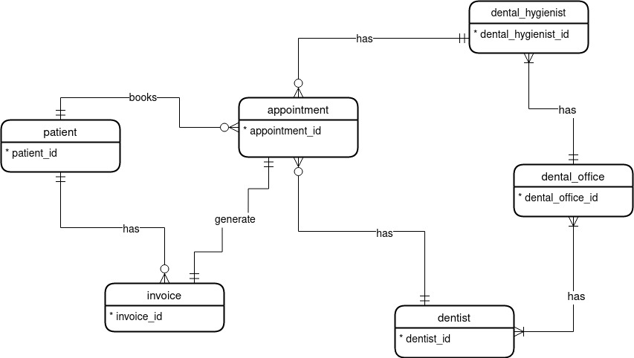

* **Logical Modeling :**

1. Identifying attributes and domains for entities and relationships:

|  |  |  |
| --- | --- | --- |
| **Entity** | **Description** | **Domain** |
| **dental_office** | The office which provides dental service. |  |
| Attributes:  dental_office _id  name  address  phone | Identifier for entity, SK, PK  Name of office  Address of office  Valid phone no. of office | Auto Generated  Text  Text  Number |
| **dentist** | Dentist information |  |
| Attributes:  dentist _id  name  email  phone | Identifier for entity, SK, PK  First Name, Last Name of Dentist  Valid email  Valid Phone no. | Auto Generated  Text  Text  Number |
| **dentist_availability** | Dentist availability at particular office at particular date |  |
| Attributes:  availability _id  dentist_id  dental_office_id  date | Identifier for entity, SK, PK  Dentist Code (FK)  Dental Office Code (FK)  Valid date of availability of dentist | Auto Generated  Valid id from dentist table  Valid id from dental_office table  Date |
| **dental_hygienist** | Information about dental hygienist |  |
| Attributes:  dental_hygienist _id  name  phone  dental_office_id | Identifier for entity, SK, PK  First Name, Last Name of Dental Hygienist  Valid phone no.  Dental Office code (FK) | Auto Generated  Text  Number  Valid id from dental_office table |
| **patient** | Patient information |  |
| Attributes:  patient _id  patient _name  email  phone  address | Identifier for entity, SK, PK  First Name , Last Name  Valid email  Valid Phone no.  Address code (FK) | Auto Generated  Text  Text  Number  Valid id from city table |
| **city** | Information about cities |  |
| Attributes:  city _id  zip_code  city_name | Identifier for entity, SK, PK  Zip code of city  Name of city | Auto Generated  Number  Text |
| **appointment** | Appointment information about patient |  |
| Attributes:  appointment _id  patient_id  dentist _id  dental_hygienist_id  datetime_of_appointment  service | Identifier for entity, SK, PK  Patient Code (FK)  Dentist Code(FK)  Dental Hygienist Code(FK)  Valid date and time for appointment  Service type | Auto Generated  Valid id from patient table  Valid id from dentist table  Valid id from dental_hygienist table  Timestamp  Text |
| **invoice** | Invoice information for appointments |  |
| Attributes:  invoice _id  patient _id  appointment_id  datetime_of_invoice  amount | Identifier for entity, SK, PK  Patient Code (FK)  Appointment Code (FK)  Valid date and time of invoice.  Cost for appointment | Auto Generated  Valid id from patient table  Valid id from appointment table  Timestamp  Number |

2. Logical model :

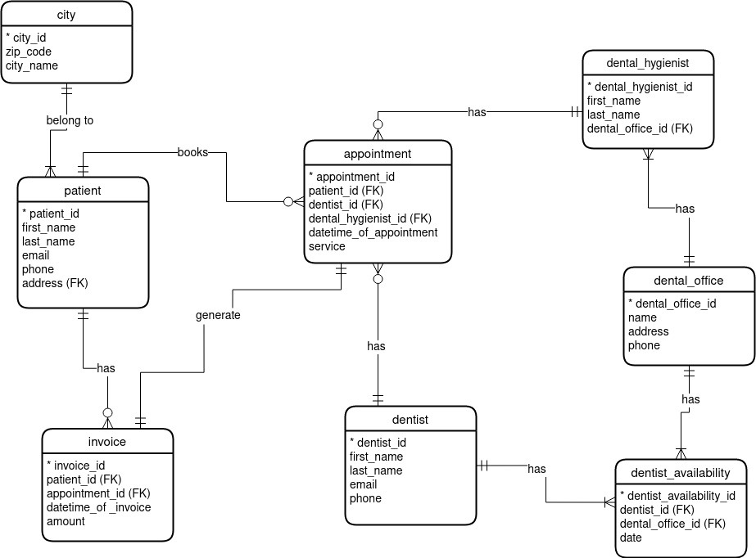

* **Physical Modeling :**

Here, I implemented required entities and relations into Postgresql relational database.

DROP DATABASE if EXISTS dentist_appointment;

CREATE DATABASE dentist_appointment;

**-- dental office**

CREATE TABLE dental_office(

dental_office_id serial PRIMARY KEY,

name VARCHAR(150) NOT NULL,

address VARCHAR (150) NOT NULL,

phone int NOT NULL

);

SELECT * FROM dental_office ;

INSERT into dental_office VALUES (1,'Jawlakhel Office','Jawlakhel,Kathmandu',5090000);

INSERT into dental_office VALUES (2,'Putalisadak Office','Putalisadak,Kathmandu',5091111);

**-- dentist**

CREATE TABLE dentist(

dentist_id serial PRIMARY KEY,

first_name VARCHAR(50) NOT NULL,

last_name VARCHAR(50) NOT NULL,

email VARCHAR(150) NOT NULL,

phone int NOT NULL

);

SELECT * FROM dentist;

INSERT into dentist VALUES

(1,'Rajan','Giri','rajan@gmail.com',984100000),

(2,'Pranav','Pudasaini','prav12@gmail.com',984300000),

(3,'Mohit','Bhatta','mohit@gmail.com',984311111),

(4,'Saphal','Shakha','safal@gmail.com',984312346),

(5,'Samyog','Shah','samyog@gmail.com',984343434);

**-- dentist_availability**

CREATE TABLE dentist_availability(

dentist_availability_id serial PRIMARY KEY,

dentist_id int NOT NULL,

dental_office_id int NOT NULL,

available_date date,

CONSTRAINT fk_availability_dentist FOREIGN KEY(dentist_id)

REFERENCES dentist(dentist_id),

CONSTRAINT fk_availability_dentalOffice FOREIGN KEY(dental_office_id)

REFERENCES dental_office(dental_office_id)

);

SELECT * FROM dentist_availability ;

INSERT into dentist_availability VALUES

(1,1,1,'2021-09-11'),

(2,1,2,'2021-09-18'),

(3,2,1,'2021-09-12'),

(4,2,2,'2021-09-16'),

(5,3,1,'2021-09-11'),

(6,3,2,'2021-09-12'),

(7,4,1,'2021-09-18'),

(8,4,2,'2021-09-11'),

(9,5,1,'2021-09-13'),

(10,5,2,'2021-09-19');

**-- dental_hygienist**

CREATE TABLE dental_hygienist(

dental_hygienist_id serial PRIMARY KEY,

first_name VARCHAR(50) NOT NULL,

second_name VARCHAR(50) NOT NULL,

phone int NOT NULL,

dental_office_id int NOT NULL,

CONSTRAINT fk_hygienist_office FOREIGN KEY(dental_office_id)

REFERENCES dental_office(dental_office_id)

);

SELECT * FROM dental_hygienist dh ;

INSERT into dental_hygienist VALUES

(1,'Ram','Giri',985100000,1),

(2,'Prem','Prajapati',984300000,1),

(3,'Mohan','Lal',984333333,2),

(4,'Sita','Siwakoti',984156656,2),

(5,'Sa','Shah',984332404,2);

**-- city**

CREATE TABLE city (

city_id serial PRIMARY KEY,

zip_code int NOT NULL,

city_name VARCHAR(50) NOT NULL,

unique(zip_code),

unique(city_name)

);

SELECT * FROM city;

INSERT into city VALUES

(1,44600,'Kathmandu'),

(2,44800,'Bhaktapur'),

(3,44700,'Lalitpur');

**-- patient**

CREATE TABLE patient(

patient_id serial PRIMARY KEY,

first_name VARCHAR(50) NOT NULL,

last_name VARCHAR(50) NOT NULL,

email VARCHAR(150) unique NOT NULL,

phone int unique NOT NULL,

address int NOT NULL,

CONSTRAINT fk_patient_city FOREIGN KEY(address)

REFERENCES city(city_id)

);

SELECT * FROM patient p ;

INSERT into patient VALUES

(1,'Ram','Shr','ram@gmail.com',5055000,1),

(2,'Sita','Ghr','sita@gmail.com',565654,1),

(3,'Hari','Sree','hari@gmail.com',985000,2),

(4,'Sam','Sri','sam@gmail.com',8055000,3),

(5,'Hom','Shpp','hom@gmail.com',855000,2),

(6,'Jam','Sho','jam@gmail.com',895000,3),

(7,'Tan','Shy','tan@gmail.com',55000,1),

(8,'Raju','Sho','raju@gmail.com',98008,2);

**-- appointment**

CREATE TABLE appointment(

appointment_id serial PRIMARY KEY,

patient_id int NOT NULL,

dentist_id int NOT NULL,

dental_hygienist_id int NOT NULL,

datetime_of_appointment timestamp NOT NULL,

service VARCHAR(100),

CONSTRAINT fk_appointment_patient FOREIGN KEY(patient_id)

REFERENCES patient(patient_id),

CONSTRAINT fk_appointment_dentist FOREIGN KEY(dentist_id)

REFERENCES dentist(dentist_id),

CONSTRAINT fk_appointment_hygienist FOREIGN KEY(dental_hygienist_id)

REFERENCES dental_hygienist(dental_hygienist_id)

);

SELECT * FROM appointment ;

INSERT into appointment VALUES

(1,1,3,4,'2021-09-12 10:00:00','Removing Teeth'),

(2,3,5,1,'2021-09-13 9:15:00','Plaster Teeth'),

(3,4,2,3,'2021-09-16 1:00:00','Cleaning teeth'),

(4,8,4,1,'2021-09-18 12:00:00','Filling'),

(5,2,1,1,'2021-09-11 11:00:00','Regular checkup'),

(6,7,4,3,'2021-09-11 1:30:00','Wire fit'),

(7,1,2,1,'2021-09-12 3:00:00','Removing Teeth');

**-- invoice**

CREATE TABLE invoice(

invoice_id serial NOT NULL,

patient_id int NOT NULL,

appointment_id int NOT NULL,

datetime_of_invoice timestamp NOT NULL,

amount int NOT NULL,

CONSTRAINT fk_invoice_patient FOREIGN KEY(patient_id)

REFERENCES patient(patient_id),

CONSTRAINT fk_invoice_appointment FOREIGN KEY(appointment_id)

REFERENCES appointment(appointment_id)

);

SELECT * FROM invoice;

INSERT into invoice VALUES

(1,1,1,'2021-09-11 10:00:00',2000),

(2,3,2,'2021-09-12 9:15:00',5000),

(4,4,3,'2021-09-14 1:00:00',2000),

(5,8,4,'2021-09-16 12:00:00',3000),

(6,2,5,'2021-09-09 11:00:00',2000),

(3,7,6,'2021-09-10 1:30:00',10000),

(7,1,7,'2021-09-11 3:00:00',2000);

**-- DQL**

**-- all patients**

SELECT * FROM patient p ;

**-- all dentist**

SELECT * FROM dentist d ;

**-- all dental_hygienist**

SELECT * FROM dental_hygienist dh ;

**-- all the dental_offices**

SELECT *

FROM dental_office;

**-- dentist availability at offices ;**

SELECT da.dentist_availability_id ,

concat( d.first_name,' ',d.last_name) as Dentist ,

available_date,

doff."name"

FROM dentist_availability da

JOIN dentist d

on da.dentist_id = d.dentist_id

JOIN dental_office doff

on da.dental_office_id = doff.dental_office_id ;

**-- all appointments information with dentist, dental_office and dental_hygienist**

SELECT * FROM appointment a ;

SELECT appointment_id ,

concat(p.first_name,' ',p.last_name) as patient ,

concat( d.first_name,' ',d.last_name ) as Dentist,

concat(dh.first_name,' ',dh.second_name) as Dental_Hygienist,

do2."name"

datetime_of_appointment ,

service

FROM appointment a

JOIN patient p on

a.patient_id = p.patient_id

JOIN dentist d on

a.dentist_id = d.dentist_id

JOIN dental_hygienist dh on

a.dental_hygienist_id = dh.dental_hygienist_id

JOIN dental_office do2 on

dh.dental_office_id = do2.dental_office_id